# CREATE A DATABASE IN CLOUDANT DB

|  |  |
| --- | --- |
| **Date** | 21 October 2022 |
| **Team ID** | PNT2022TMID07784 |
| **Project Name** | Project - IoT Based Safety Gadget for Child  Safety Monitoring and Notification |
| **Maximum Marks** | 4 Marks |

**Create A Database In Cloudant DB**

**Aim:** To create a database in Cloudant DB to store location data.

# Steps followed:

* Logged in to IBM Cloud account
* Navigated to `./resources`
* Clicked on the “Create Resource +” button
* Searched for “Cloudant”
* Chose the “Lite Version” and clicked on “Create”

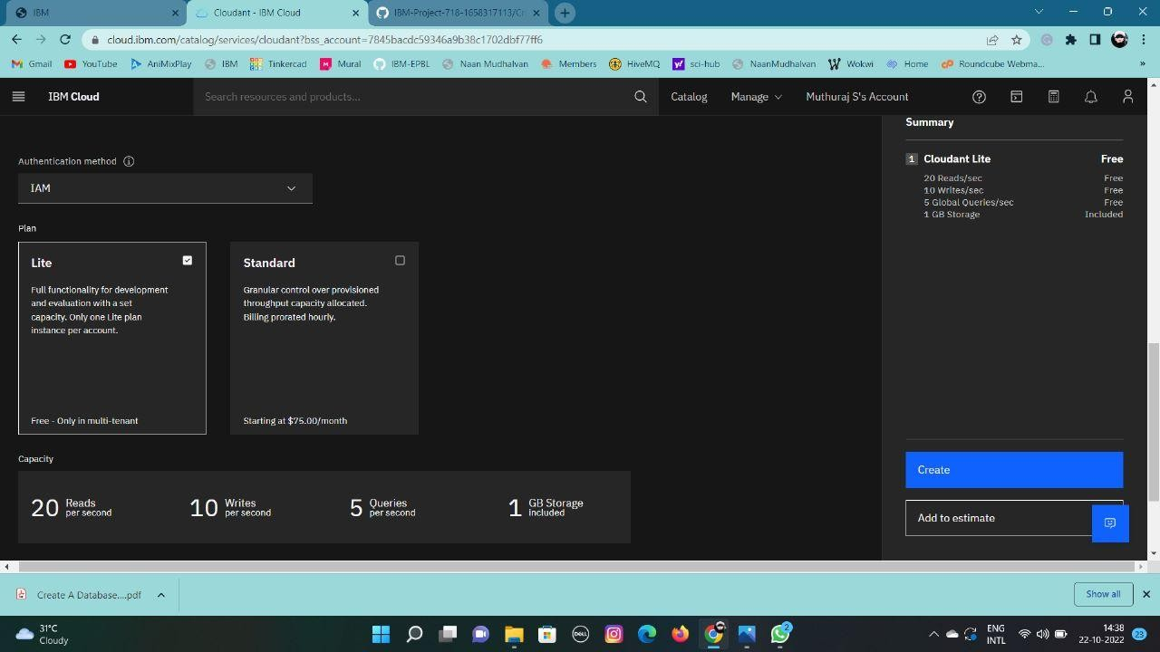

* The Cloudant database resource was created successfully

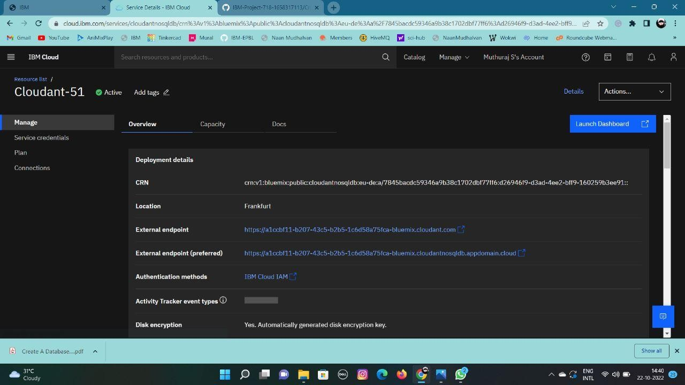

* Clicked on Launch Dashboard

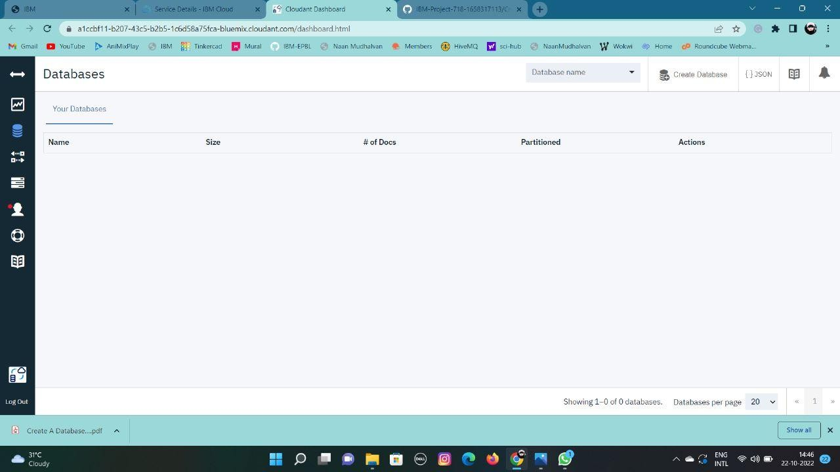

* Clicked on “Create Database”. Entered “meowman” as the database name and the “Non-partitioned” option

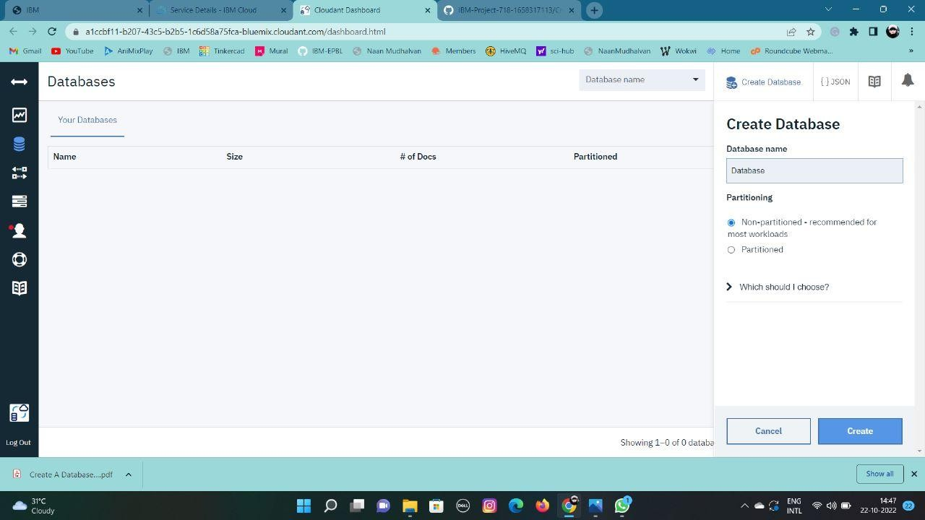

* The database “meowman” was created successfully

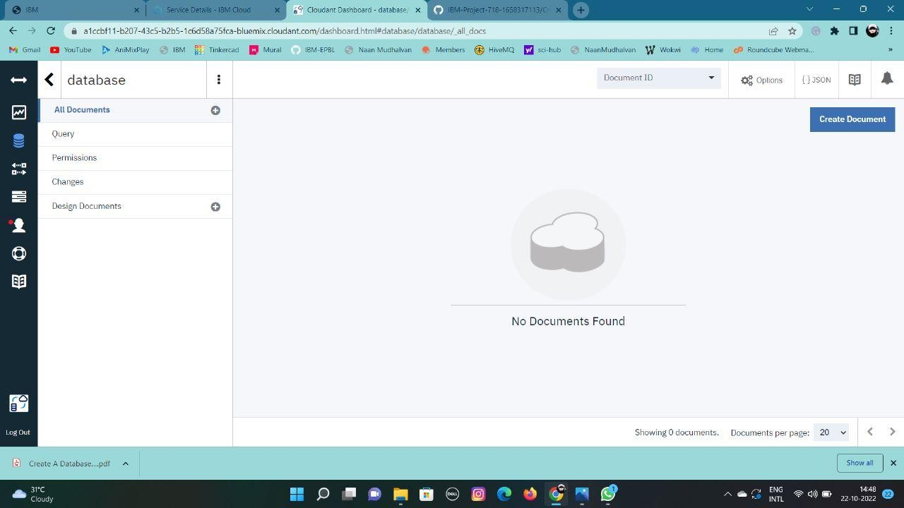

Result:

A database to store the location data was created successfully on Cloudant DB

